Lift up Jesus

Eternal Father, I offer You the Body and Blood, Soul and Divinity of Your dearly beloved Son, Our Lord Jesus Christ, in atonement for our sins and those of the whole world. (Chaplet of Divine Mercy)

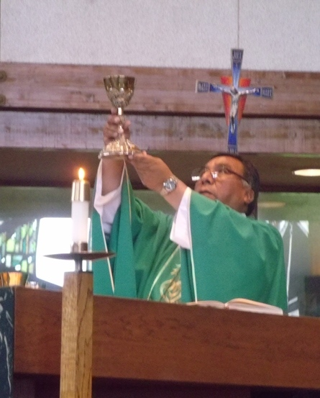

As we lift up Our Lord in the Eucharist we want lives centered on Jesus in service to others. We are earthen vessels who hold an incalculable treasure. We face daily spiritual combat but we do not give up.

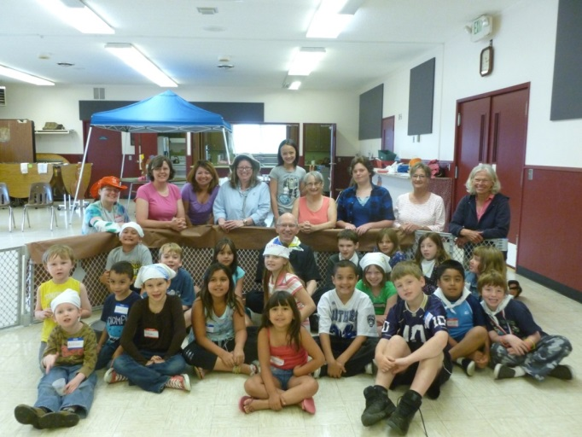

Love One Another

These things I have spoken to you, that my joy may be in you, and that your joy may be full. This is my commandment, that you love one another as I have loved you. Jn 15

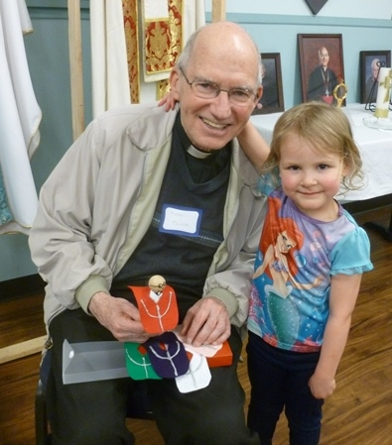
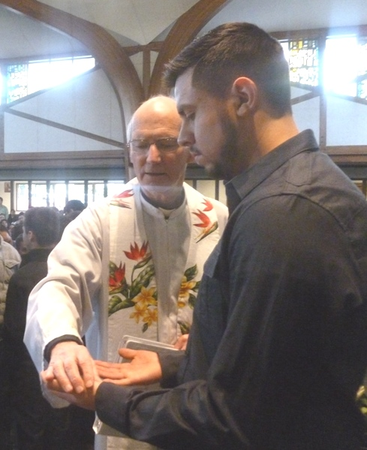

Make Disciples

Go, therefore, make disciples of all nations, baptizing them in the name of the Father, and of the Son, and of the holy Spirit, teaching them to observe all that I have commanded you. Matt 28

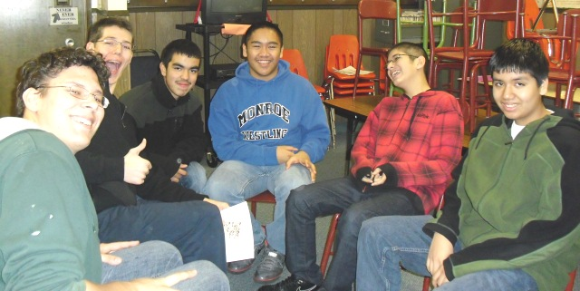
Parish Vision

Lift Up Jesus
Love One Another
Make Disciples

Blessed to live in this beautiful valley, we are Christians, in union with Pope Francis and Archbishop Sartain, who strive to lift up Jesus, love one another and make disciples.

In our twelve month listening and discernment process we heard major concerns including children, music, buildings, marriage and welcoming. During the year 2016-2017 we will give particular focus to the top three concerns: Unity, Youth and Spirituality

Goals for 2016-2017

Unity

Strengthen the unity of the Body of Christ through the collaboration of cultures in faith, culture and language, to foster active participation in the life of St. Mary of the Valley Catholic Church. Unity of parishioners is demonstrated by an increase of families who participate in Masses & event of a different culture.

Youth

Establish a “United Youth Group” encompassing both Middle School and High School in alignment with the USCCB goals on youth ministry and in coordination with the Archdiocesan Youth Ministry

Spirituality

Without spirituality – that is, lives centered on Jesus – we will quickly fall into discouragement. In 2016-2017 we will promote prayer before Jesus in Blessed Sacrament to increase of numbers of those who dedicate at least one hour a month to Eucharistic Adoration.

Prayer for our parish

Father of Mercy, we lift up the Body and Blood, Soul and Divinity of your Son, Jesus. May he lift us from discouragement to hope, sorrow to joy. By the Spirit enable us to love one another and become his disciples.

As we invite our young people to become disciples of Jesus, make us one so people will believe you sent us. Make our parish a source of hope and healing in this Valley.

Like Mary may we live lives centered on Jesus in service to others. Send your angels to defend us in the spiritual battle. We ask this through Jesus in the power of the Holy Spirit, one God forever and ever. Amen.

